Section 3 - Conscious vs. Subconscious Mind
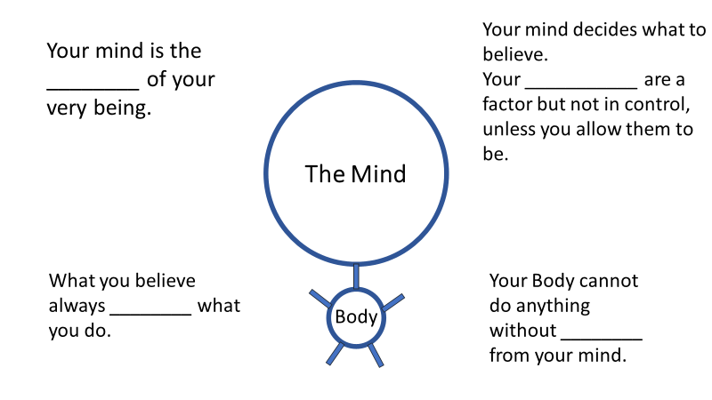

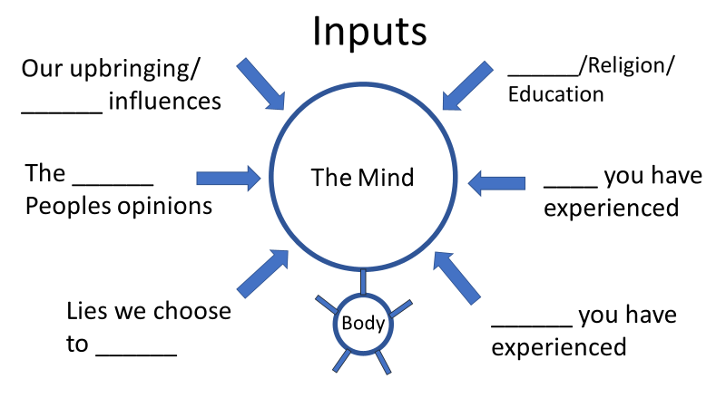

- By default, we are programmed to allow our consciousness to be controlled and _________ by news and events outside of ourselves.
- It is estimated that somewhere between ___-___% of our daily behaviors are outside of our conscious awareness.
We think on autopilot.
- This means that most of our decisions and _________ are made ahead of time based on our subconscious programming.
We have default, or automatic thoughts.
- The biggest threat to our _________ is not what will physically harm you, it is the thoughts that will take you captive and derail you from purpose.
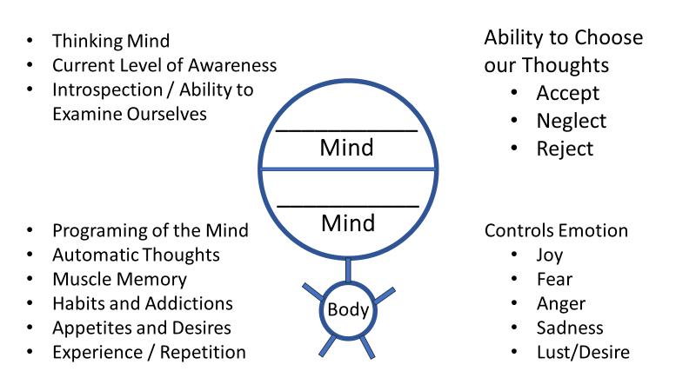
- Your subconscious is built on what you have _______ learned, decided and experienced.
Growth cannot be _________ by the subconscious mind.
- If you are not _________ aware of your behavior, then you are not a conscious _________ in the results of your actions.

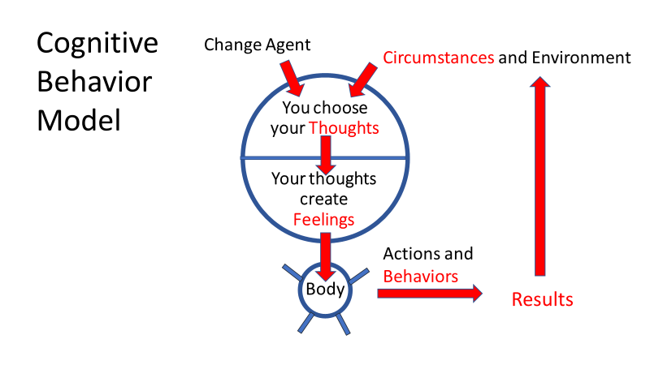
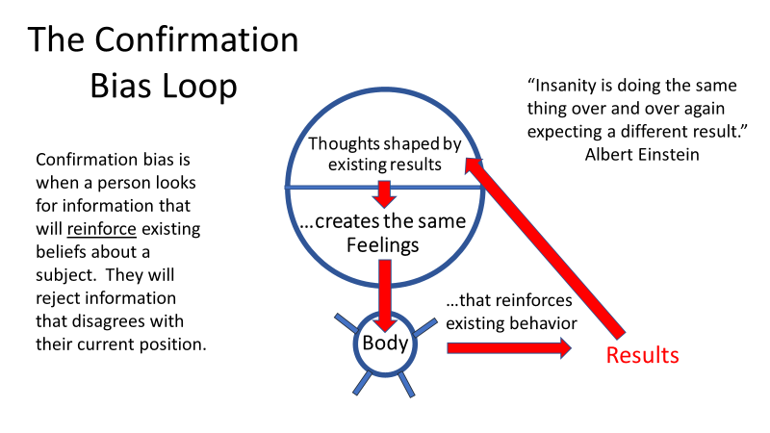

- Cause and Effect - Every thought that your conscious mind chooses to _______, your subconscious mind must _______.
- Your conscious mind is the master over the subconscious mind.
- Coaching requires that we help bring _________ awareness to our clients, so they can make the conscious choice to change.
Notes:______________________________________________________________________________________________________________________________________________________________________________________________________________________________________________________________________________________________________________________________________________________________________________________________________________________________________________________________________________________________________________________________________________________________________________________________________________________________________________________________________________________________________________________________________________________________________________________________________________________________________________________________________________________________________________________________________________________________________________________________________

