Coaching Training
Section 6

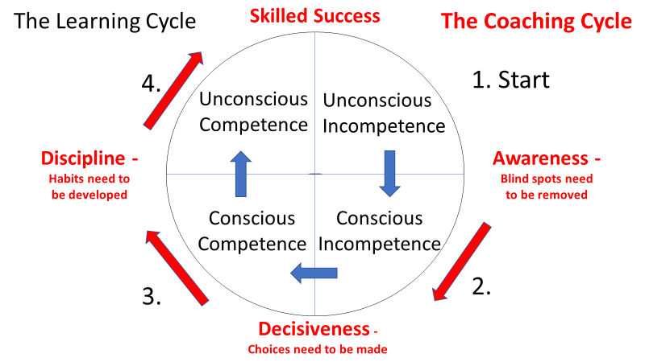

Notes:______________________________________________________________________________________________________________________________________________________________________________________________________________________________________________________________________________________________________________________________________________________________________________________________________________________________________________________________________________________________________________________________________________________________________________________________________________________________________________________________________________________________________________________________________

Stage 1: Unconscious Incompetence

• You don’t know what you don’t know.
• When unconsciously incompetent you simply aren’t ________ that you’re not able to do something.

For example, a young child isn’t ________ ________ of the fact that they can’t drive, because they haven’t even considered the process of driving.

Stage 2: Conscious Incompetence
• At the next stage, conscious incompetence, a person becomes aware of their existing ________, recognizing flaws and weak areas.
For example, the child becomes a teenager and becomes ________ that he or she can’t drive like slightly older teenagers or their parents.
• This is a vulnerable time that leads to a fork in the road. They will begin to ________ with incompetence or reject it.
Stage 3: Conscious Competence
• This is the beginning of the habit building stage. It takes ________ thought to be competent.
• This is where ________ improves, and effort is more conscious and deliberate.
The teenager has passed their driving test but still has to think about how they go about driving.
• It takes focus and repetition over time to build ________ ________ and muscle memory.
Stage 4: Unconscious Competence
• Finally, the person arrives at being unconsciously competent, where natural, ________, higher levels of performance are achieved entirely unconsciously.
Think of how that teenager has grown up to be you, and now think about your experience of driving.
• This is the stage that ________ begins to skyrocket.

